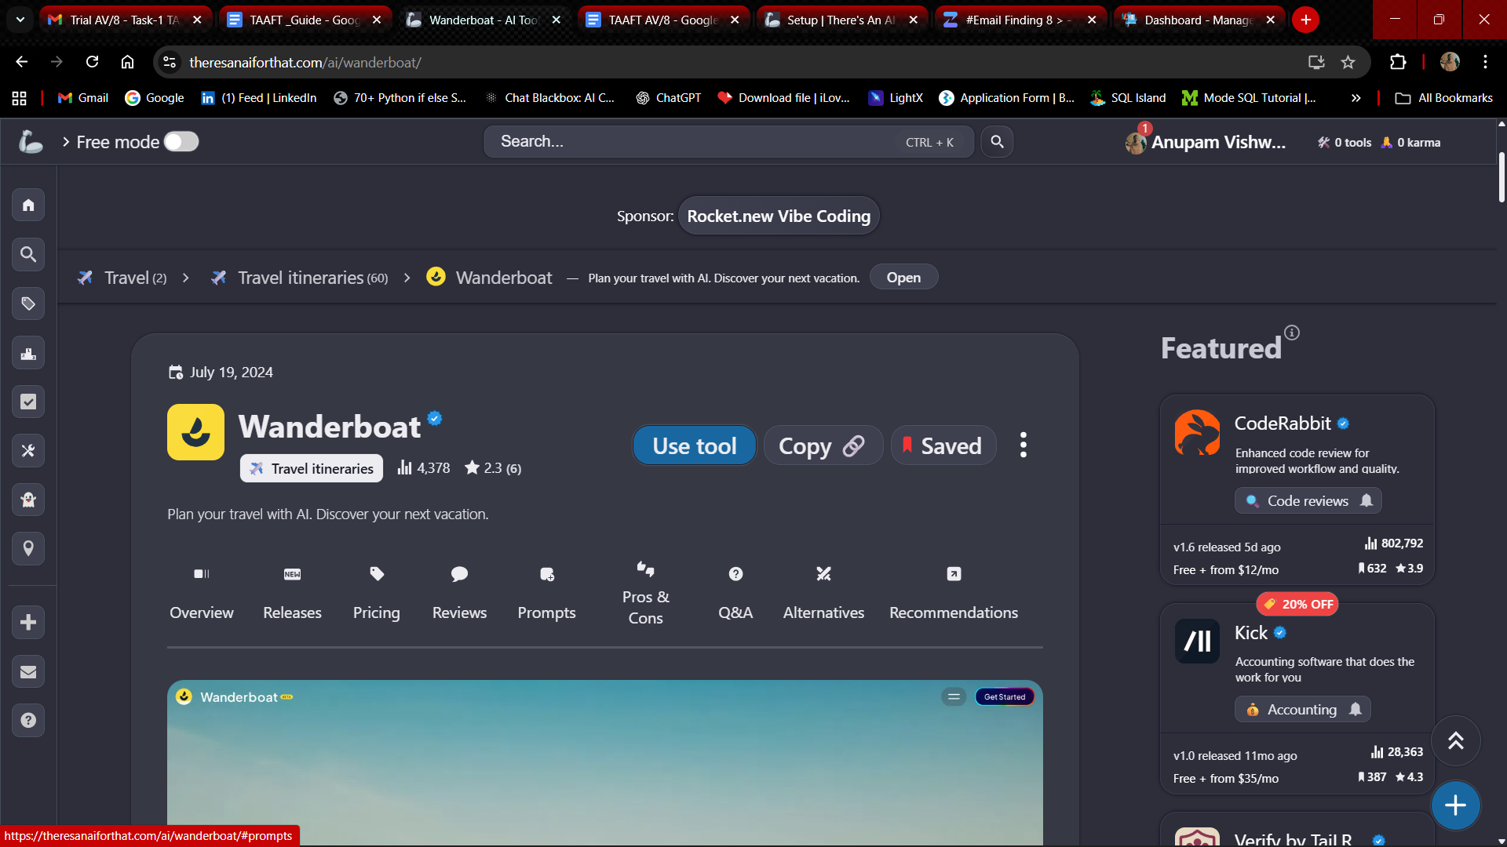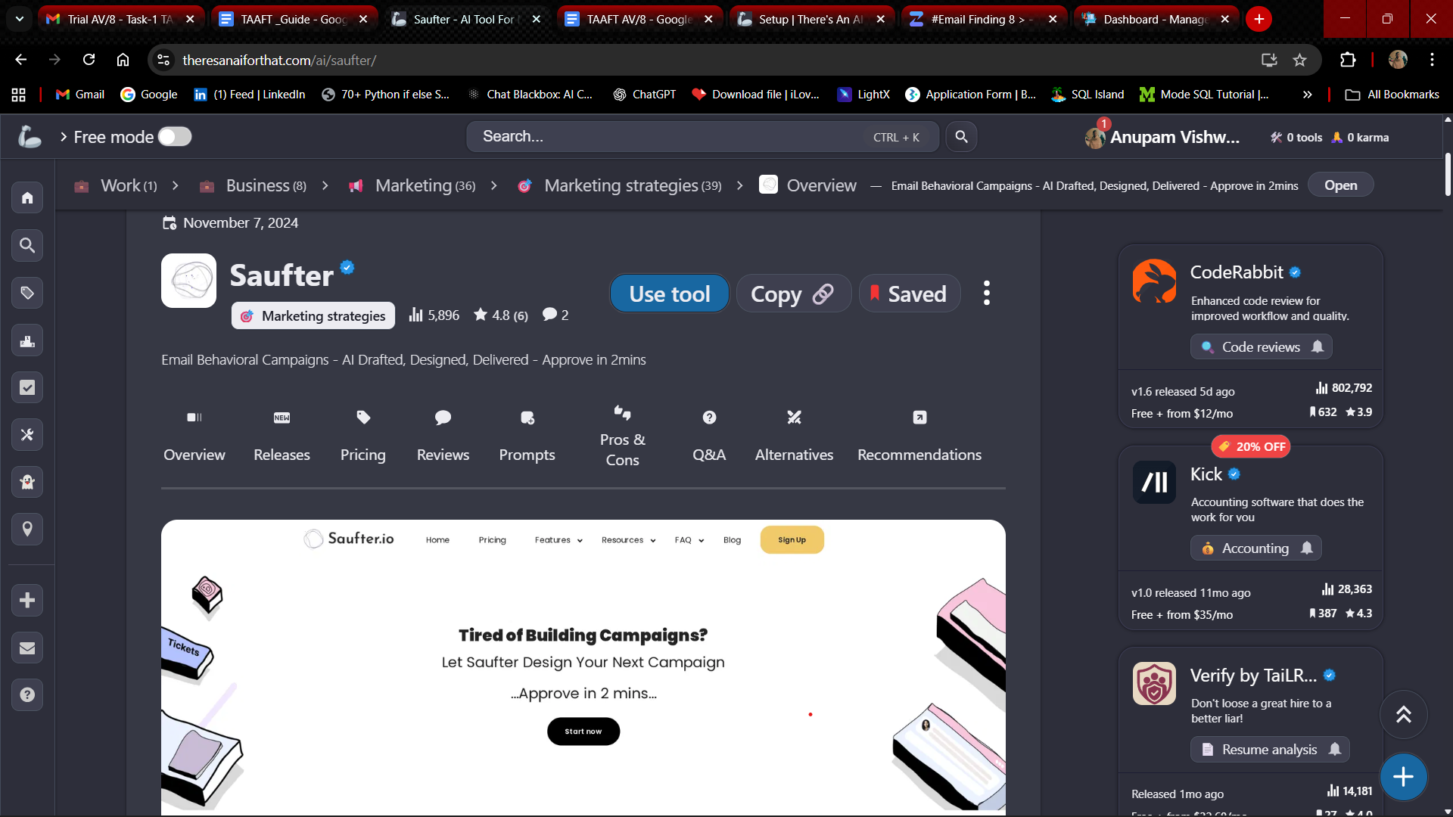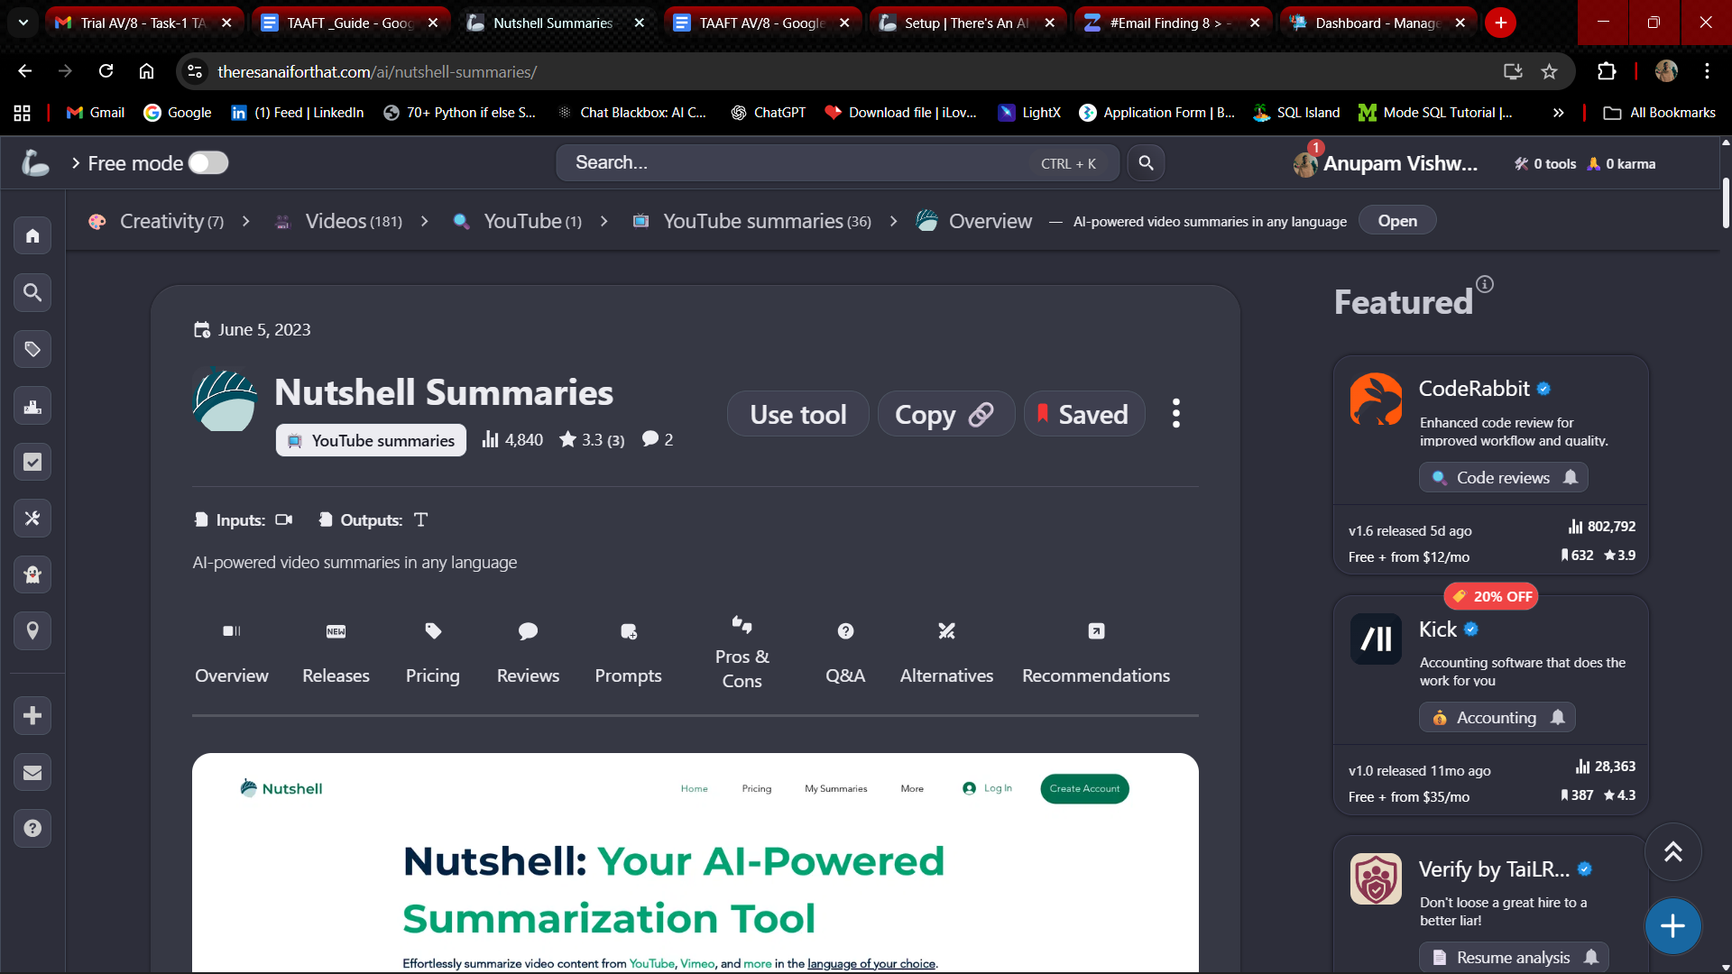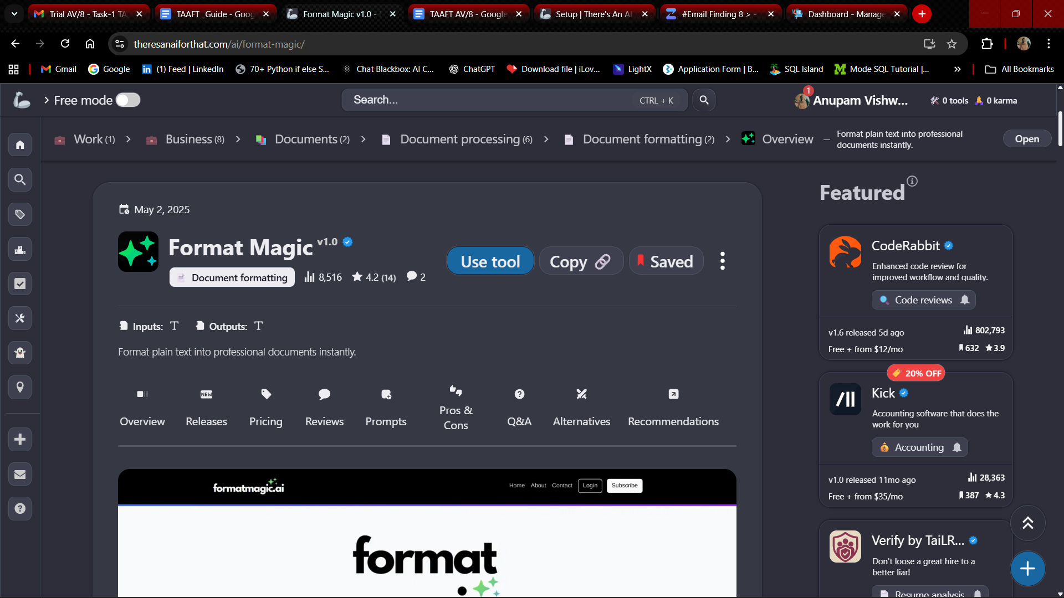

| **Tool Name** | **Direct Competitor** | **Similarity - 1** | **Similarity - 2** |
| --- | --- | --- | --- |
| **Format Magic** | GitBook | Both convert unstructured/plain input (text, notes, equations, or code) into well-formatted, structured outputs, such as documents or snippets. | Both provide template-based formatting tools with an intuitive, user-friendly design. |
| **Nutshell Summaries** | Eightify | Both use advanced NLP models to summarize long-form content (videos/articles) into concise, actionable insights. | Both support multi-language processing and timestamped highlights for better navigation. |
| **Saufter** | ActiveCampaign | Both automate customer/sales engagement using AI-driven email and behavioral (or lead-based) campaign workflows. | Both offer personalization, segmentation, and analytics dashboards to optimize campaign performance. |
| **Wanderboat** | TripPlanner.ai | Both leverage AI to analyze user preferences, past travel data, and trends to create optimal itineraries. | Both apply AI algorithms to optimize routes, schedules, and provide personalized travel recommendations. |